Organizational Mapping Tool

FACILITATOR GUIDE

Table of Contents

Introduction……………………………………………………………………….………2
Who Participates?..................................................................................................2
All Staff……………………………………………………………………….…..2
When Should Board Members Participate?................................................2
A Note about Large Groups……………………………………………………3
Facilitator’s Responsibilities…………………………………………….……………...3
How Long Does the OMT Take?...........................................................................4
How to Conduct the Exercise…………………………………………………….….…4
Longer Version……………………………………………………………..……4
Part 1: Setting the Context………………………………………………..……4
Sample Script for Introduction to the OMT Session……………………...….5
Part 2: Completing the Survey & Reaching Consensus ….…………….…..6
Facilitation Tips for the Consensus Rating …………………………………..7
Recommendations on Managing Time for the Longer Version ….…….…..9
Part 3: Prioritizing Exercise………………………………………………….….9
Part 4: Next Steps and Resource Identification……………………………..11
Shorter Version …………………………………………………….…………..12
Preparing the Report …………………………………………………….…………….12
Sharing the Findings..……………………………………………………………….….13
Additional Considerations ………………………………………………………..…....13
A Note About Tallying Answers Ahead of Time…………………………….. 13
Conflict of Interest……………………………………………………………….13
Technology Issues………………………………………………………………14
Adapting the OMT for Each Group…………………………………………….14
Using the OMT with Networks ……………………………………….………………..14
Checklist of Agreements and Decisions to be Made with Each Organization
Before You Start ………………………………………………………………….….…16
Introduction

This guide is for facilitators of the Organizational Mapping Tool (OMT), a facilitated, participatory self-assessment survey. The OMT provides the opportunity for an organization to consider itself as a whole, asking what works well and what could be improved; it then helps to identify collectively priority areas for improvement and steps for addressing them, all through organization-wide consensus. It is not meant to be a strategic planning tool, but rather provide input for an eventual institutional development plan for capacity building. It is intended for organizations of different sizes and levels of capacity—from small or recently founded to mature and complex organizations. By the end of the process, the organization should have:

- A clear sense of how it sees itself on key aspects of organizational development;

- A short list of highest priorities for institutional strengthening;

- A set of outcomes that would result from strengthening each of these prioritized areas;

- Key steps the organization can take on its own to make progress in each area; and

- A list of specific requests that could be made of a funder in a grant proposal for each area (if appropriate).

Who Participates?

All Staff

The OMT is meant to be filled out by all staff—programs and administration—and, if appropriate, by available board members, since different perspectives are valuable in understanding an organization’s strengths and areas for growth. Some groups ask if cleaning or other service staff should be included. Unless there is a good reason to exclude them, and when in doubt, it is recommended to err on the side of inclusion.

The process is best done with one person who is not an employee or board member leading as a facilitator.

When Should Board Members Participate?

Each organization should decide whether or not to include some or all members of the board (or other governance body) in the exercise. As a rule, board members who can speak to the operational detail of the exercise are the most appropriate participants. However, some organizations choose to have only staff participate. This decision depends in part on whether or not board members have adequate information to weigh in on the topics covered; whether board participation might inhibit staff participation; and whether it makes sense to involve the board in discussions of management issues that may exceed, and in some cases confuse, their role and mandate.

That said, organizations are encouraged to use the OMT as an opportunity for taking a hard look at the effectiveness of their governance. Sharing the results of the OMT with board members—even if they do not participate in the session itself—may also be a useful way to engage the board (or other body) on governance and/or other organizational strengthening challenges.

Facilitators should encourage and may assist organizations to assess the risks and opportunities of board involvement in the OMT and think creatively about how best to engage board members.

A Note about Large Groups

If the organization is very large (for example, bigger than 50 persons), conducting the exercise with a smaller group of staff who represent different perspectives, areas and levels of the organization may work best. It is not recommended to divide up a large organization and conduct parallel OMT processes.

The organization should identify relevant criteria for selecting the representative group, with the help of the facilitator, if needed. Such criteria might include: gender; race; ethnicity; caste; class; culture; combination of field and office staff, program and administrative staff; levels of seniority and time in the organization. It is important to select individuals who are most likely to be equanimous, constructive and willing and able to represent others’ as well as their own thinking.

The selection process for the representative group may take different forms, but should be as transparent and democratic as possible. For example, staff may self-nominate or be nominated by supervisors or peers. To the extent possible, it is recommended that those being represented weigh in on who will carry out this role for them (for example, staff in a particular program area or office may vote for their own representative).

To begin the session, each person should say whom they represent, and the group should ensure that all relevant perspectives are, indeed, represented. During the session, the person representing other staff may: 1) simply represent the perspective of his/her group as best he/she can, or 2) act as a proxy for a group who shared their individual survey answers with him/her ahead of time. See below for specific facilitation tips for representative groups.

After the session, it is recommended that facilitators be slightly more detailed in the “Comments” section in the final OMT report to capture the main points of the discussion, keeping in mind it will be shared with people who were not in the room during the discussion. Facilitators should encourage the organization’s leadership to have an all-staff meeting (virtual or other) after the session to explain the OMT process, take questions on the report from all staff (whether present at the session or not), and let participants give a sense of the process and the conversations to their peers. One possible sequence for that meeting: 1) presentation of perspectives represented to see if the group feels any perspective is missing; 2) all read the OMT report; 3) clarifying questions; 4) small groups to detect points that sparked greatest enthusiasm, agreement or disagreement; 5) in groups organized by team, “What can my team do to support implementation of next steps?”

Facilitator’s Responsibilities

The external facilitator’s primary responsibilities involve ensuring that the process moves along quickly and comes to necessary conclusions. S/he:

- Encourages participants to think about the whole institution, beyond their program, role or area

- Listens for places where conclusions can be drawn and the conversation can move on

- Ensures that quieter voices get heard within the group

- Leads the prioritizing exercise to conclusion

- Records the conclusions of the deliberations and summarizes the main points of discussion in a final report (found at the end of the OMT survey)

How Long Does the OMT Take?

The OMT exercise has four steps:
- Setting the context and explaining the OMT (15 to 30 minutes)
- Completing the survey and reaching collective consensus (anywhere from 4 to 7 hours, including breaks)
- Prioritizing three items from the survey to work on as an organization (30 minutes to 1 hour)
- Identifying next steps and resources needed for each of those three items (30 minutes to 2 hours)

Timing included in parentheses is an estimate and depends largely on three factors:
- Whether or not participants read and complete the survey before coming together, which adds an hour or more if they have not filled it out previously (both methods are described below).
- How much time is allowed for discussion of each survey item and how easily the group tends to reach consensus.
- Level of detail expected in the prioritization and next steps exercise at the end.

Each organization should decide how much time to invest. A session of six to eight hours (with breaks) works well when participants complete the survey on their own prior to the meeting. If the group has not completed the survey beforehand, they will generally need at least a full day for that work only. One alternative is to cover steps 1 and 2 in one day, and do steps 3 and 4 on a separate day (or 1 through 3 in one day and 4 on a separate day).

How to Conduct the Exercise

Here we describe both a “longer version” and a “shorter version,” the main difference being whether or not the participants fill out the survey before or during the meeting.

LONGER VERSION
Survey completed in meeting

Part 1: Setting the Context (15-30 min)

- Welcome everyone, do a round of introductions and briefly introduce yourself. The organization's leader might want to say a few words as well, including sharing any relevant institutional news, thanking the staff for participating, actively encouraging them to do so openly throughout the exercise, and explaining how the OMT fits into the organization’s current and future plans. The leader should also, ideally, announce that the OMT final report will be shared with all staff once completed.

- Hand out print versions of the survey to each participant.

Note: Some groups are sensitive to the use of paper and will prefer that participants fill out the survey on a laptop, tablet or other device. Facilitators should agree on the best modality with the organization’s leadership beforehand.

- Provide a brief, initial introduction to the session, including:

  - An overview of the survey, its purpose and topics
  - Clarity about the strengths and limitations of the exercise to help manage staff expectations, given that it opens up a lot of issues and needs. This is an important moment to reinforce that the discussions will serve as important input into the organization’s institutional strengthening priorities, but that no decisions will necessarily be made at the session.
  - A summary of expected outcomes for the day, including a prioritized list of action steps for strengthening the organization
  - A brief summary of how the day will go, and what steps will occur afterward (when the report will be completed, who will receive and approve it, who will share it with the donor, if pertinent). Make sure to announce (or have the organization’s leadership announce) that the report will be shared with everyone once completed.
  - Clarity about the facilitator’s role, including ensuring even participation, helping all voices be heard, and striking a balance between allowing for some in-depth discussion and keeping the process agile. This could include mention and/or discussion of how the facilitator and/or the group will address various power dynamics in the room.

- Answer initial clarifying questions

- Set up ground rules to guide the group’s discussion and remind participants of the participatory and open nature of the OMT. Suggested ground rules might include:

  - Even participation
  - Active listening
  - Balancing inquiry and advocacy in our interventions (so as not to sway participants’ ratings with too much “advocating” for one answer)
  - Respect all voices
  - Be concise
  - Come back from breaks and meals on time
  - Cell phones off except for emergencies

Sample Script for Introduction to the OMT Session

- Nature and Purpose of the OMT
- The purpose of the OMT is for organizations to assess their institutional strengths and weaknesses in a collective manner, generating organizational wide consensus.
- It is an institutional self-assessment, not an organizational or performance evaluation.
- It covers a wide variety of topics (list them).
- It allows organizations to decide collectively which topics are top priority for future action and what steps they can take to address them.

- Today’s Outcomes
- A consensus rating on each of the points or subcategories included in the survey
- A list of the top three priority topics that the organization wants to address
- Desired outcomes for each, and also concrete next steps for addressing them
- What actions the organization can take on its own and what resources it may need or choose to request from a donor

- Strengths and Limitations of the OMT
- The OMT is relatively quick, agile, and highly participatory.
- It is low-tech and meant to be used across a variety of contexts.
- It allows for all staff to provide input and opinions, but does not allow for a deep dive into all topics nor does it result in a full institutional development plan.
- The consensus ratings are simply indicative of the collective view of the group and so we will not worry excessively about each one; the discussion and collective understanding is the most important aspect of the exercise.

Sample Script for Introduction to the OMT Session
(continued)

- Process and Clarifications
- Describe how the session or sessions will occur.
- Mention and openly address issues related to power dynamics in the room, if appropriate.
- Describe your role as facilitator.
- Describe all post-session steps (how you will elaborate the report, when the report will be ready, who will receive and approve it, that it will be circulated to all staff.)
- Add any clarifications about confidentiality, who else will receive the report (such as board members or a donor, if applicable) and how the results will and will not be used.

Part 2: Completing the Survey & Reaching Consensus (4 - 7 hours)

- Clarify the meaning of consensus and “consensus rating” in the context of the OMT. Suggested language: “What we are going to do now is get a sense of how people voted and then seek to agree on a rating that reflects the collective opinion of the group. This is not based on a strict tally or an exact average. Rather, first, we will get a sense of the group’s opinions and then you will decide together the best rating. Not everyone needs to agree; you just need to be able to live with it. On the outside chance that we can’t, I will make a note of any minority or dissenting voices in the Comments section, respecting individuals’ confidentiality. Please remember that the richness of the OMT lies in the discussion and not in the particular rating.”

Tip: We recommend putting a definition of consensus for the OMT on a flipchart or otherwise posting it in the room as a reminder throughout the session (for example, loose consensus, or “the sense of the group”).

- Ask the participants to rank each of the sub-categories in the Mission and Strategy section on their own. Encourage participants to answer all questions even with partial information, but they should leave blank those questions about which they do not have sufficient information to answer. Give about 10 minutes for participants to read and complete.

Note: Participants should be told they can choose to check the circle in between two ratings (as in the circle between Basic and Moderate).

- Reconvene the group and help them identify a consensus rating for each subcategory within the Mission and Strategy category that reflects general agreement as to where the organization ranks. See suggested dynamics to help the group reach consensus in the grey box. Some subcategories will take longer than others if consensus is hard to reach. It is the role of the facilitator to strike the right balance between allowing for needed discussion and helping the group avoid getting bogged down in each subcategory (see suggestions on timing below).

Note: The facilitator has a few options for how to record the consensus ratings and the most salient points of the discussion during the exercise, which will ultimately be submitted in the report form found at the end of the OMT survey:

- The consensus ratings can be marked using the PDF form on a computer or other device, or by hand on a printed version.
- The notes on the discussion can be logged directly in the same PDF form, or taken by hand, or logged in a computer or other device, not using the PDF (for example, in a Word document).

- Repeat for each category: the group completes the survey for that category in silence, and then the facilitator helps them reach collective consensus. The group should complete all sections using the consensus process, except Executive Leadership. These questions are more politically sensitive and are often not best discussed collectively.

- Ask participants to complete the Executive Leadership section anonymously

- Collect the individual answers to these questions. (Participants may send the PDF to the facilitator if they filled out this section electronically.)

Note: Executive directors ideally should not be in the room when the questions around leadership are completed.

Note: If the organization has more than one executive director (for example, two co-directors), ask participants to mark their ratings thinking of the leadership as a team, then use the comments section to make specific references to the individuals, if needed.

Facilitation Tips for the Consensus Rating

One of the key roles of the facilitator is to help create a safe space for discussion, manage power dynamics, ensure even participation and bring out the quieter voices in the group. Here are some ideas for helping to make that happen. If the facilitator detects that this is not occurring during the session, he/she should actively remind the group (especially the leadership, if necessary) about the spirit of the OMT.

- Conduct a “lightning round” for each sub-category, in which each participant calls out the level they chose, without explanations (for example, “Basic,” “Basic,” “Moderate,” “Moderate,” “Basic to Moderate,” “Moderate,” etc.)
  - Start each round with a different person and change direction frequently in order to get different voices heard first
  - After the lightning round, ask “What are people hearing?”
  - Reflect back to them the number of times that each level was named (you can keep tabs of this on a sheet of paper during the lightning round)
- Have participants indicate which level they chose with a show of hands for each level (starting with “Strong”) and those in between (e.g., “between Moderate and Strong”). This is particularly recommended when working with a group larger than 25 people, though it also works well in smaller groups.
- Have participants stand along a continuum or in different places in the room to reflect their rating
- Use dot stickers on flip charts to visually capture the range of ratings for some of the sub-categories
- Straw poll with electronic voting technology (if available)
- Where you see outliers, call on those persons to share their perspective: “Can you tell me why you scored this as you did?” or “Can someone that marked “Basic” share why they scored it that way”?

Facilitation Tips for the Consensus Rating (continued)

- Focus on those who have relevant expertise (for example, the accountant when rating financial administration). But call on expert voices (and/or senior management) last, not first, so that others also feel free to speak out.
- Particularly for larger groups, you may choose to break up participants into triads, or three or four smaller sub-groups around “clusters” of topics. If participants voted on flipcharts, each group reviews a cluster of categories and tries to identify a consensus rating for each sub-category to report back to the plenary. Other tips for working with small groups include:

  - Beware of the amount of time involved in using small groups.
  - Begin the OMT session with facilitation of one or more consensus ratings in plenary so that participants get a sense of how the discussion is supposed to go and what is meant by “reaching consensus,” before they are asked to mirror it in small groups, without your active facilitation.
  - Look for overlap in consensus ratings among all small groups.
  - Focus the discussion on where there is more divergence.
  - Have participants self-organize in small groups around topics to which they want to contribute (ensuring that everyone feels that they can opine even if it is not their area of expertise).

- Conduct a “negative poll”: “Does anyone disagree with moving on?” or “Who can’t live with moving on?” Two approaches may be:

  - Thumbs up, down or sideways. Thumb sideways means I don’t agree but I can live with it. For those with thumbs down: “what would it take to move you from thumbs down to sideways?”
  - Fist to Five, where number of fingers shows level of agreement. Zero (fist) is “There is no way I can accept this consensus rating,” Three is “I don’t really agree, but can move on,” and 5 is “I fully agree with moving on.”

- To capture dissenting voices, or when consensus is difficult to reach:

  - Move to different places of the room to reflect how in agreement or disagreement each person is and have an “open mic” moment to say why
  - Use a “parking lot” to record dissenting voices (and make sure that these are later reflected, in an anonymous fashion, in the comments section in your final report)
  - Have participants listen in to the discussion of a small group of people that agree on a rating, then ask them to share if they dissent
  - Provide post-its for people to share dissent in a more anonymous fashion

- It is helpful to have an easily visible list of the topics to be covered on the wall and check them off as you go along so that all participants can see how many remain to be covered. You may also get permission from the group at the start of the session to use a timer to help with time management.

- Because it’s a long exercise, the facilitator needs to keep the process as agile as possible. Diverse methodologies that involve physical movement to get the energy flowing and visuals are important, as are occasional breaks, stretching, etc.

Recommendations on Managing Time for the Longer Version
- The survey includes 14 sections. If possible, try to keep to 20 minutes section (roughly 5-10 minutes for reading plus 10-15 minutes for establishing consensus for the various sub-categories).

- Some sections might take longer (if the section includes more sub-categories, or the discussion takes longer), so allow for some overall buffer time in your agenda.

- At 20 minutes per section the exercise takes a little over 4.5 hours, plus breaks. You might plan for six hours if you have a larger group or expect more discussion time.

Part 3: Prioritizing Exercise (30 minutes to 1 hour)

Once all sections of the tool are completed you will start the prioritizing exercise. There are many ways to do this; here is one method.

- Ask each participant to go back through the survey (excluding Leadership) on their own and log what they see as the organization’s first, second, and third priorities for institutional strengthening under the section “Prioritizing Exercise,” found after the Executive Leadership category. Remind participants that priorities are not necessarily what is most urgent—or the biggest weakness—but rather the most important issue for the organization to focus on in the coming period.

Note: Participants may focus on the larger capacity category (e.g. Advocacy, Learning and Evaluation) unless they want to specify an issue raised in a subcategory.

- Before beginning the tallying exercise, explain to participants that the numbers are merely suggestive, and do not automatically define the priorities.

- Then ask each person to report what they ranked as first, tallying the individual answers on a large sheet or board in the front of the room, and repeat this process for second and third priorities. Note that this information can also be gathered by show of hands for each category, or by voting on flipcharts. In the first image, frequency of votes are captured by “sticks” (one stick for each mention). In the second image, those frequencies are converted to digits to facilitate the subsequent multiplication.

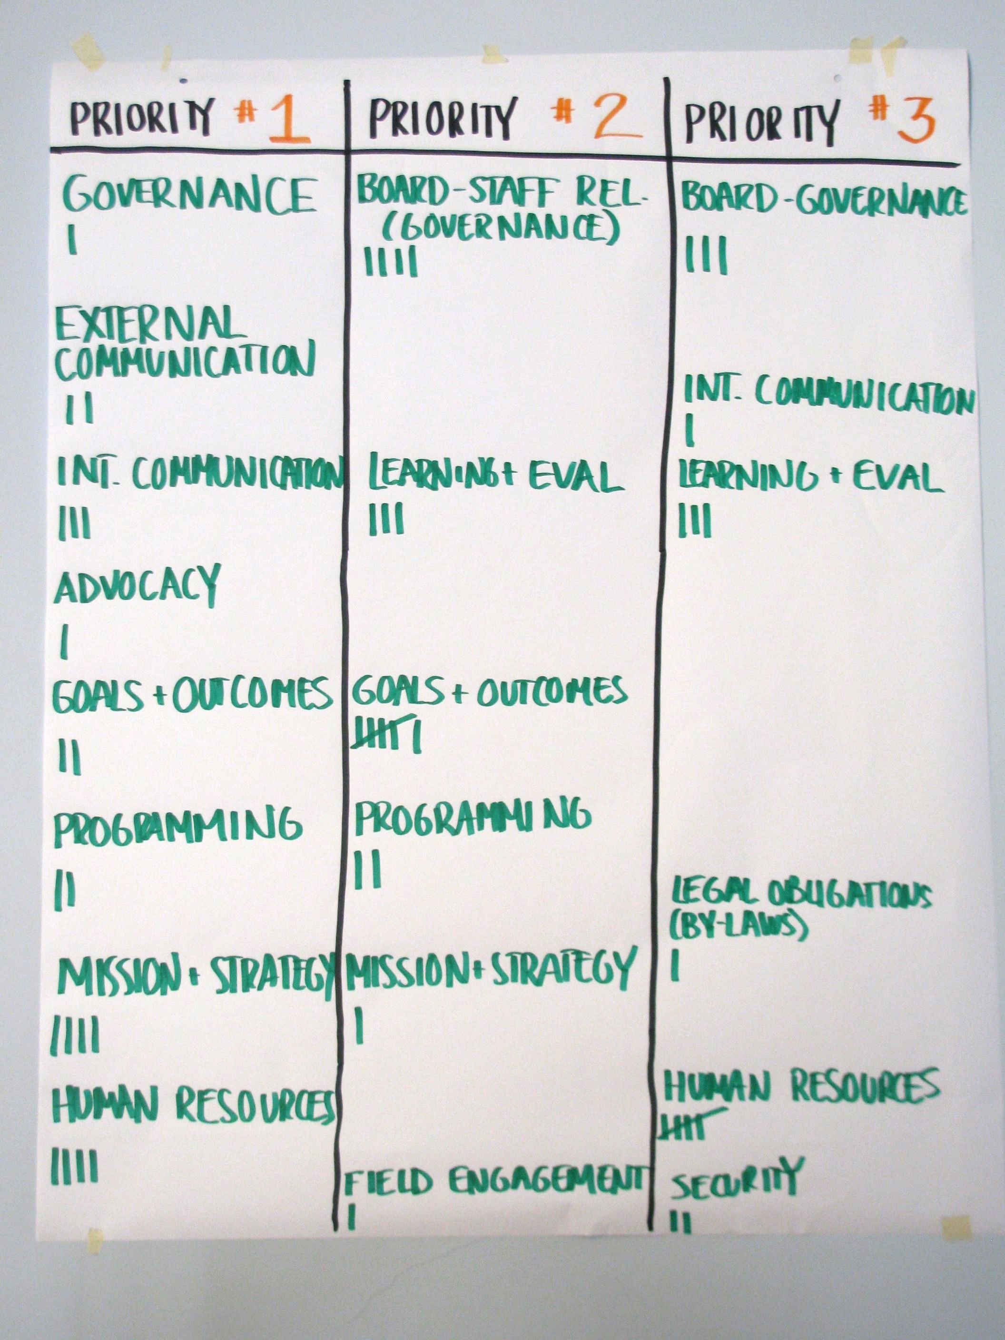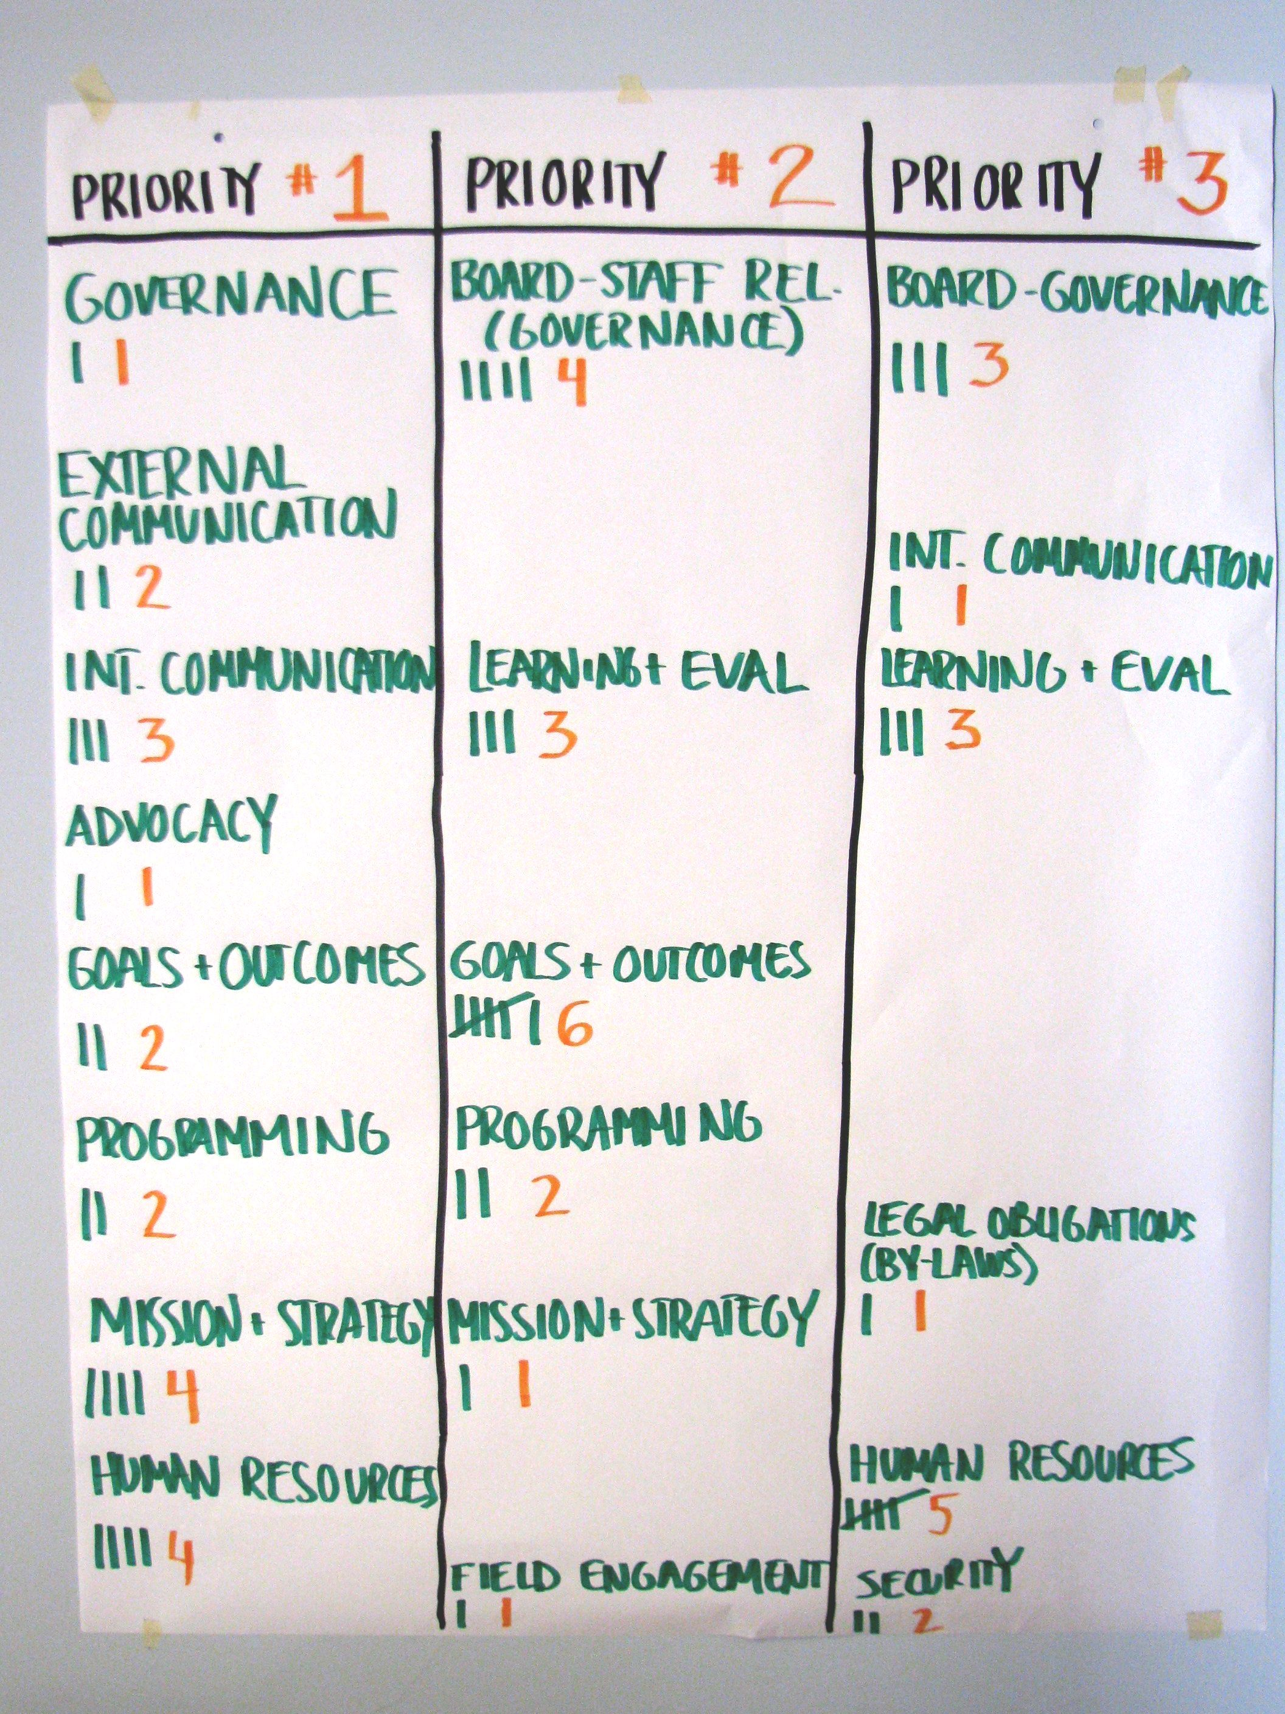

- Sum the information in two ways:

- Overall frequencies (e.g., how often was Communications mentioned overall)

- A weighted frequency in which first priorities weigh more than second ones, and second more than third

Note: To do this, every time a category is considered first priority, it should receive three points; for second, it should receive two; and for third, one point.

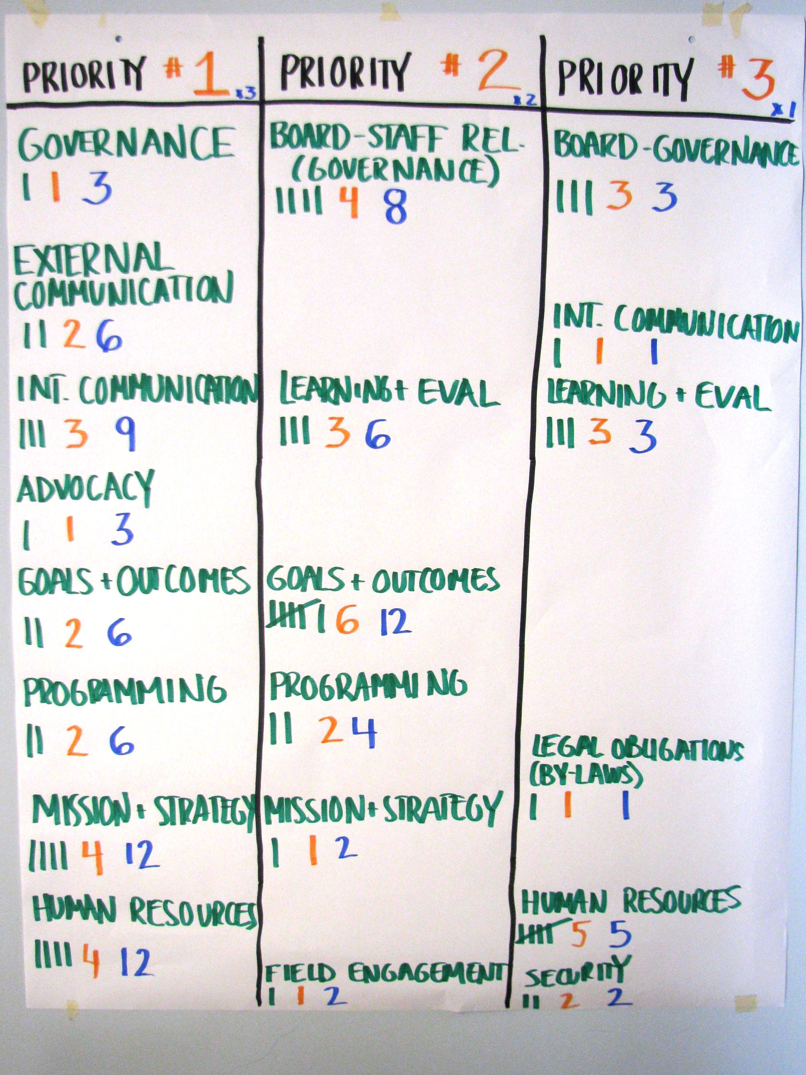

In this image, the weighted points are logged throughout the chart. For example, 1 x 3 equals 3 points for Governance as priority one;
2 x 3 equals 6 points for External Communication as priority one;
4 x 2 equals 8 points for Governance as priority two, etc.

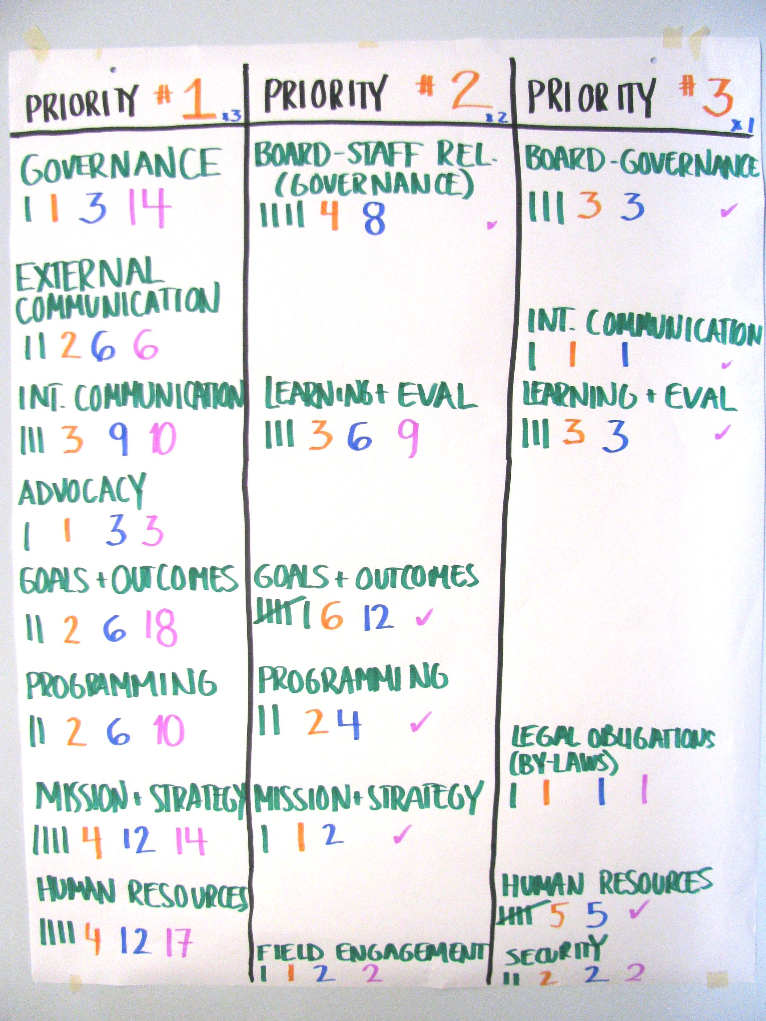

In this image, the points are summed for each topic (for example, 14 points for Governance, six points for External Communication, etc.).

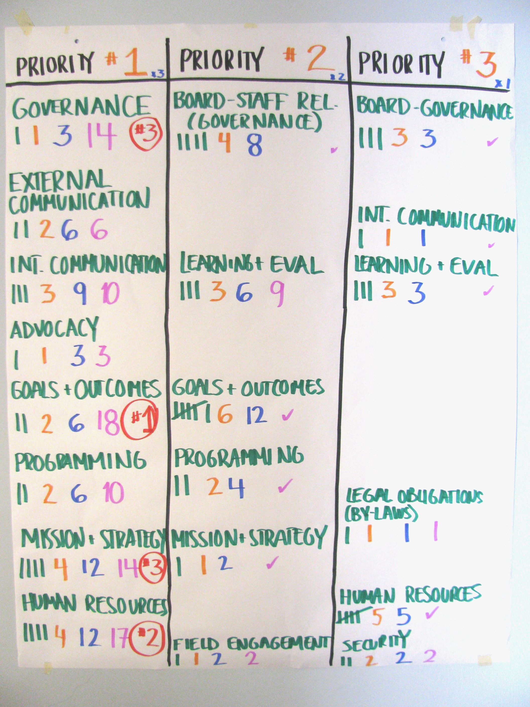

In this image, the top three priorities are indicated by the circled numbers (Priority one is Goals and Outcomes with 18 points; priority two is Human Resources with 17 points; and Governance and Mission and Strategy tied for priority three with 14 points each).

Tip: To move this step along and foster participation, you may want to have someone from the organization help you calculate and/or check the weighted frequencies.

Tip: The facilitators may use and later transcribe flipcharts for both the prioritization and next steps exercise, writing up the results electronically using the report form at the end of the OMT survey. The prioritization exercise worksheet at the bottom of the form tallies the weighted frequencies automatically.

- Ask the group to note trends in terms of organizational priorities for institutional strengthening.

- Remind the group that the numbers are just indicative, and turn them over for discussions with questions like: “What are you seeing?” “Does anyone think that something else should be among the top three priorities?” Conclude by identifying the organization’s first, second, and third priorities.

- Remind participants to answer and turn in the last question on the OMT Survey (located right after the Executive Leadership section), with feedback on the session. The facilitator may include anonymous, aggregate comments about staff feedback in his/her final report.

Part 4: Next Steps and Resource Identification (30 minutes to 2 hours)

Once the group has identified the organization’s top three priorities, the facilitator engages participants in a discussion of next steps.

The facilitator helps the group:

- Identify the outcomes they would want to see within a few years for each of the three priorities (ask participants to answer: for this priority, “what does success look like?”)
- Specify steps they would need to take to realize these outcomes
- Identify follow-up actions for each of the priorities (including persons responsible and deadlines)
- Consider which resources the organization already has to help them realize their outcomes
- Identify those resources that require external support
- If there is time, articulate the request they might make, where appropriate, to a funder in a proposal (this may also be done by the Director or other staff person after the exercise)

All of this may serve as input for an eventual Institutional Development Plan, which may accompany a proposal to a funder, if additional resources are needed to realize the outcomes.

If there is time, the facilitator may consider dividing participants into smaller groups to do the work related to next steps and follow-up actions. Depending on time, the smaller groups may report-back to the plenary and/or hand in written recommendations to the organization’s leadership.

SHORTER VERSION
Survey completed before coming to meeting

For the shorter version, the facilitator:

- Has an initial introductory meeting with participants to distribute the survey, explain the desired outcomes, and welcome questions, or sends an introductory email to this effect.

Note: It is recommended to distribute the survey approximately 72 hours in advance of the collective exercise (enough time for the staff to complete it, but not so far in advance that they are likely to discuss it among themselves before the exercise).

- Asks each participant to complete the survey and bring it to the full group meeting. Encourage participants to answer all questions even with partial information, but they should leave blank those questions about which they do not have sufficient information to answer.

Note: Participants should be told they can choose to check the circle in between two ratings (as in the circle between Basic and Moderate).

- Uses the first hours of the meeting to have the group come up with their consensus answers as described above. Having completed the survey prior to meeting, you could allocate approximately 15 minutes per section. At 15 minutes per section the exercise takes at least between 3.5 and 4 hours, plus breaks. The rest of the dynamics (prioritization and next steps) are the same.

The advantage of having people complete the survey in advance is that they have more time to read and reflect on their responses, and the in-person meeting becomes more agile.

Preparing the Report

The final report consists of the full OMT PDF, including the completed OMT survey with the consensus ratings and any comments, and the report form that appears just after the survey. After the meeting, the facilitator:

- Reviews the survey responses and makes any necessary edits

- Reviews the notes he/she took on the survey under comments and makes sure they succinctly, accurately and appropriately capture the main points of discussion

- Synthesizes the anonymous comments on Executive Leadership and makes notes about general trends

- Synthesizes and shares any relevant anonymous feedback on the session (last question after Executive Leadership)

- Fills out the report form with general information, and information on the prioritization exercise, next steps and resource identification.

Sharing the Findings

With the Organization

Once the full report is complete, the facilitator shares this with the organization’s leaders (as agreed beforehand, usually the Executive Director or equivalent, or the Executive Director and person/s in charge of organizational development) and obtains their approval of the report, making any edits, as necessary. In general, these changes should be minor, either for the sake of clarity, or choosing different words that are more appropriate for the organization’s culture and sensitivities. If the leadership proposes changes of substance or significant clarifications, the facilitator indicates that s/he will include these as an additional opinion in the report, but not change the report.

Note: Where appropriate, the facilitator discusses any significant trends from the Executive Leadership section with the leaders of the organization. Ideally, the facilitator should share this section with the leadership shortly after the exercise (within 24 hours, if possible) and before sharing the report with any other staff members.

With Donors

The report should only be shared with donors with the consent of the organization, after they have approved a final version of the report. As a rule, and unless there is an explicit agreement to the contrary, organizations, not external facilitators, should share the report with donors. When in doubt, facilitators should clarify this with the organization’s leadership.

Additional Considerations

A Note About Tallying Answers Ahead of Time

Facilitators may be inclined to create an on-line survey or other mechanism to tally individual answers before the facilitated session. While this option may save time around the consensus rating and provides greater anonymity for participants, it also affects the participatory feeling and spirit of the OMT associated with having all staff express themselves on each subcategory face-to-face, in the moment.

Conflict of Interest

Facilitators may face a conflict of interest during the prioritization exercise if they are in any way a candidate to provide institutional strengthening support to the group related to any of the categories or sub-categories. Facilitators should be extra careful to avoid steering organizations toward priorities or actions that they, as consultants, can help with, even if this represents a well-intentioned effort to help a group prioritize issues it can most easily address. It is recommended that facilitators remind the group that priorities should be chosen independent of resources available at the time. At the very least, facilitators should disclose and openly discuss this potential conflict of interest with the organization’s leadership and reassure the organization that it is free to work with any consultant and should feel no obligation to engage the facilitator in follow-up work.

Technology Issues

A note for MAC users: The OMT PDF Report Form (at the end of the OMT survey) does not work with Preview (the default PDF viewer on MAC computers). If opened using Preview, the file becomes corrupted and important fields in the report format no longer work properly. If using a MAC, you must first download Adobe and only use the OMT in Adobe. (There may be a cost for this). This is not a problem for organizations filling out the OMT survey as it only affects the report format at the end, to be completed by the facilitator.

From time to time, the OMT may also experience bugs due to changing versions of Adobe Acrobat and other PDF readers. Before sharing the PDF with the organization and before the exercise begins, the facilitator should ensure that s/he is able to mark, save, change and re-save answers to the survey (checkmarks, comments and the prioritization worksheet).

Tip: Facilitators should do a role-play test round to make sure they are familiar with the technical aspects of using the PDF.

Adapting the OMT for Each Group

Not all categories or sub-categories will apply easily to all organizations. Facilitators should help groups understand each element in a way that makes it as relevant to them as possible, for example, adapting terminology as needed. As mentioned, groups should be reminded that the tool is flexible and that the goal is to spur discussion and discern the “sense of the group” rather than focus on any specific rating. In some cases, the facilitator—in consultation with the organization’s leadership—may choose to tell participants to skip a particular section if it is clearly not relevant to them. This should be done as an exception, and on a case-by-case basis.

Tip: Facilitators should be conversant in the organization’s mission, structure, and programs and consider marking up the form with any notes related to terminology or other opportunities for adapting the tool to the organization’s specific characteristics.

Tip: Facilitators should also be aware of any recent strategic planning, organizational assessment or other institutional strengthening efforts that the organization has undertaken (or is currently undertaking), to figure out how the OMT best fits in.

Using the OMT with Networks

The OMT will likely need to be adapted in the case of networks or coalitions, which may take one of several different forms. First, the facilitator will need to determine who from the network will participate (secretariat, one representative of each member organization, etc.)

Second, facilitators should remind participants to “put on their network hat” rather than answer from the point of view of their organization only.

Also, several of the OMT sub-categories are framed more for organizations than for networks. Again, facilitators should be prepared to help groups adapt each element in a way that makes it as relevant to them as possible. Some key examples include:

Mission/program alignment – This question should allow participants to consider alignment of mission and programs across the network to ensure that network members are working in a coordinated fashion toward the mission and goals of the network.

Advocacy strategy – This question should allow participants to consider the necessity of coordinated advocacy strategies among the members of a network and an overarching strategy plan for the network as a whole.

Communications strategy – This question should consider the necessity of a coordinated communications strategy in which the network and its members are agreeing upon key network messages and audiences.

Principal governing body composition – This question should take into account that networks may have different forms of governance.

Principal governing body/staff relationship – This question should allow for the potential complications involved with the relationships between governing body members and network member staff, as not all governing body members may work directly with staff outside of the network member they represent.

Funding diversification – This question should allow for the necessary differences between the funding flows of the network as a whole and network members. Participants should also be asked to consider the interdependence of the network and its members in ensuring funding diversification.

Sufficient funding – This question should assess whether or not funds raised are sufficient to meet the needs of the network itself and its members for their participation in network activities.

Organizational structure – This question should consider that both network structure and network member structure will be critical in determining the overall health of a network.

Administrative procedures – This question should address the dynamics between a network (for example, its secretariat or other coordinating entity) and its member organizations.

Checklist of Agreements and Decisions to be Made with Each Organization
Before You Start

- Duration and date(s) of the exercise

- Who and how many will participate (staff and board), including decisions around selecting a representative group in the case of large organizations

- Date by which the facilitator will provide the final report to the organization

- Who will receive and approve the report (the Executive Director, the Executive Director and other senior management staff, the Institutional Development person, if one exists, etc.)

- Who and date by which the organization’s leadership will share the report with staff (and board, as the case may be)

- Background documents that the organization feels comfortable sharing with you. For example, the last strategic plan, organizational chart and organizational development plan (or informal list of institutional strengthening priorities that the leadership may have already developed).

- Get clarity about the group’s structure, especially if it is complex and may impact the focus of the OMT.

- Get clarity on how the OMT fits into or complements other institutional efforts underway, including, for example, strategic planning, board strengthening, or a leadership transition.

- Alert the organization’s leadership that the OMT tends to open up a variety of topics and to generate momentum and raise staff’s expectations. He/she should be prepared to announce some sort of follow-up by the end of the session.

- Logistics:

- Where the exercise will take place (location should be of appropriate size to comfortably accommodate all participants)

- If people will be required to fill out the survey beforehand, and if not, whether the group prefers to fill it out during the session electronically, manually, or a combination of both

- If the survey will be completed beforehand, date for sending out the survey and who will send the survey to staff, with what background information and instructions (for example, the facilitator may obtain participants’ email addresses from the organization’s leadership and communicate directly, or he/she may prepare the introduction and instructions for the organization’s leaders to send to their staff)

- Who provides materials (markers, flipchart paper, photocopies if relevant)

- Snack break and other meal requirements to be provided by the organization

“Organizational Mapping Tool Facilitator Guide” 2016 by Martha Farmelo and Victoria Wigodzky (based on an original version by Bess Rothenberg), is licensed under a Creative Commons Attribution 4.0 International License.
This guide is a work in progress. Any feedback or suggestions for improvement are welcome. Please write to: martha.farmelo@gmail.com and vicwigo@gmail.com.
Original design by Sen Associates

